Directories Submission:
S.no | URL | 360schooltrips Screenshot
01 | http://www.rowma.com/submit.html?c=667 | 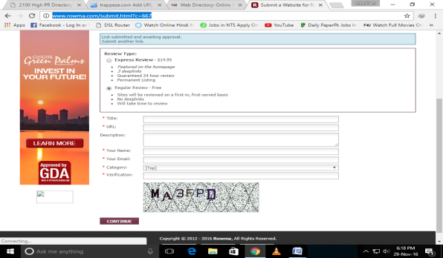
02 | http://www.1websdirectory.com/add_data.aspx | 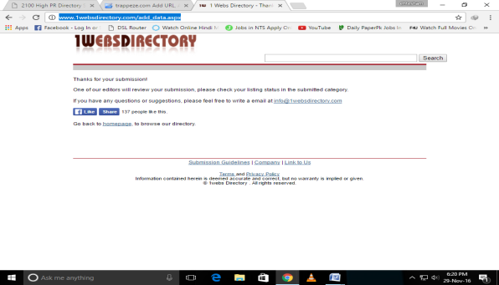
03 | http://www.seoabcs.com/submit.php?c=335 | 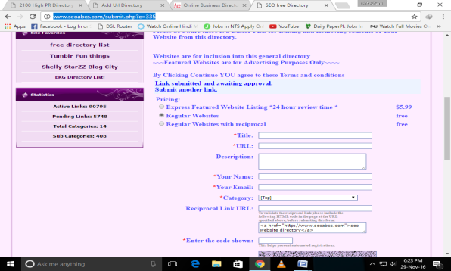
04 | http://www.acewebdirectory.com/add_data.aspx | 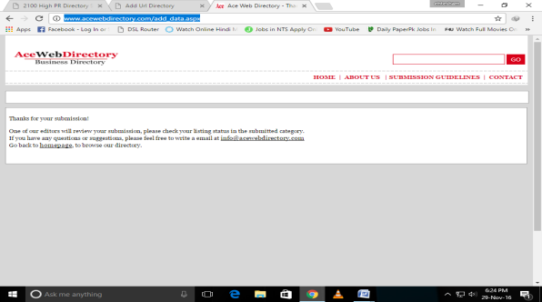
05 | http://www.iaddurl.com/submit.php?c=335 | 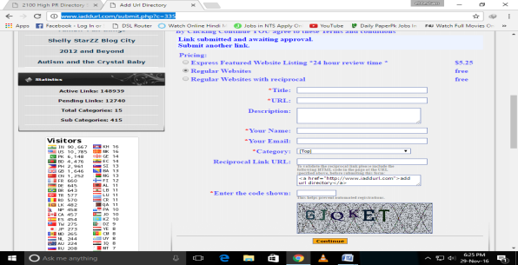
06 | http://www.lemon-directory.com/submit.php?c=20 | 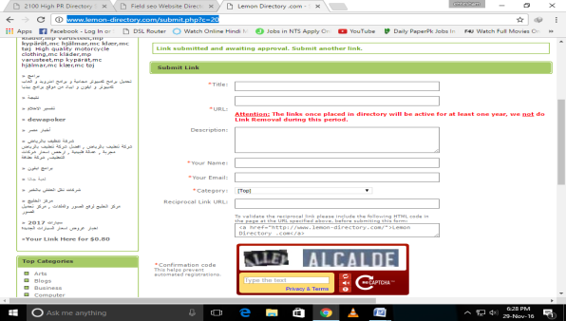
07 | http://www.submit4links.com/submit.php?c=335 | 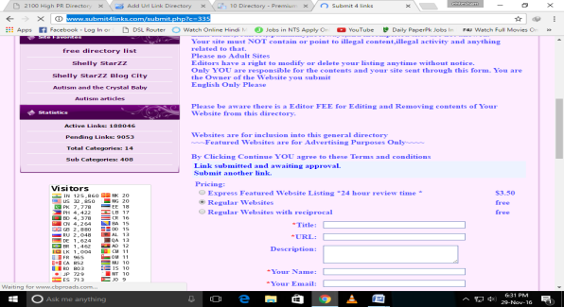
08 | http://www.correctedbyreality.com/submit.php | 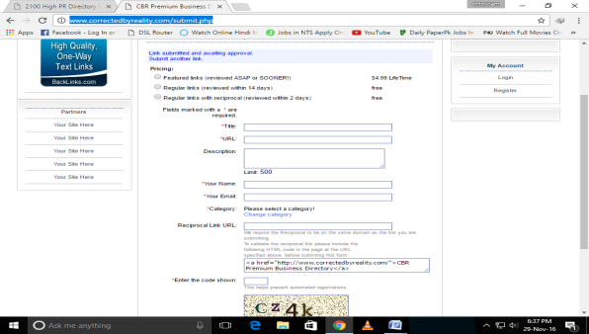
09 | http://www.textlinkdirectory.com/index.php?go=success | 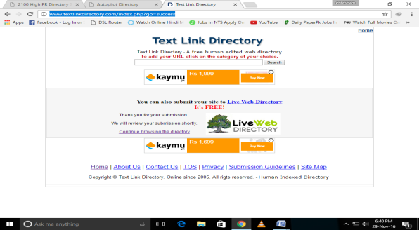
10 | http://www.autopilotdirectory.com/submit.php | 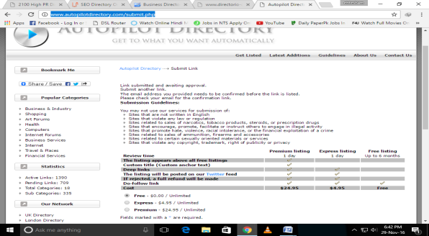
11 | http://www.addbusiness.net/submit.php?c=483&LINK_TYPE=1 | 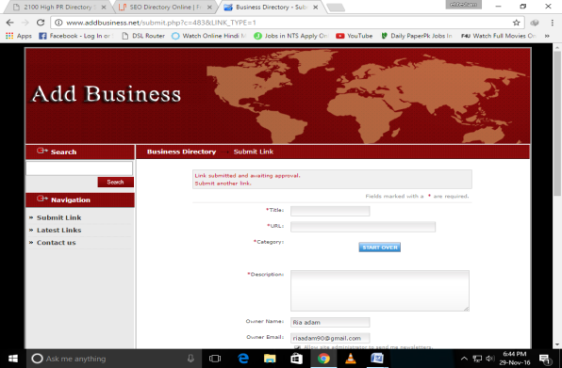
12 | http://mugro.info/submit.php?c=667 | 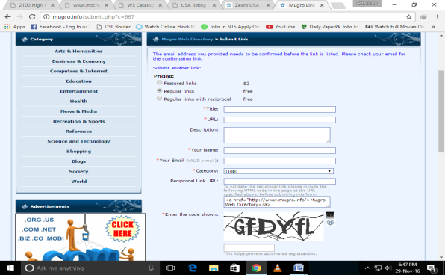
13 | http://zexro.info/submit.php?c=667 | 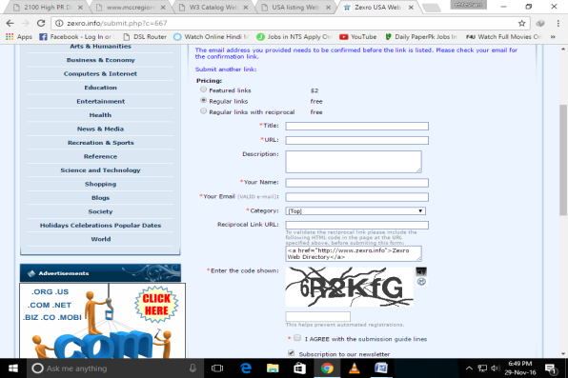
14 | http://www.usalistingdirectory.com/submit.php | 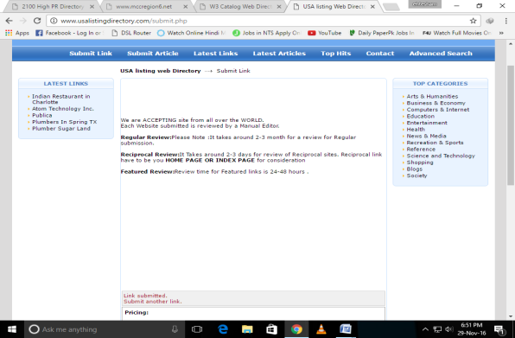
15 | http://www.w3catalog.com/submit.php | 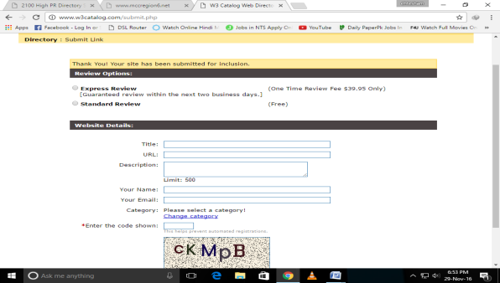
16 | http://www.ananar.com/submit.php?c=479&LINK_TYPE=1 | 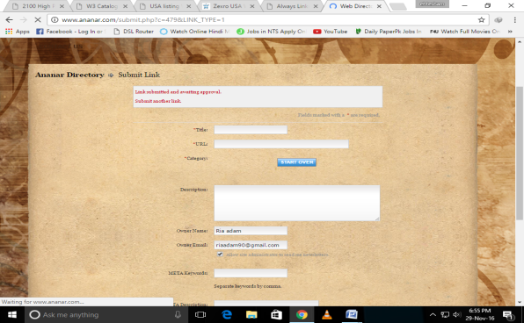
17 | http://www.alwayslinks.com/submit.php - cont | 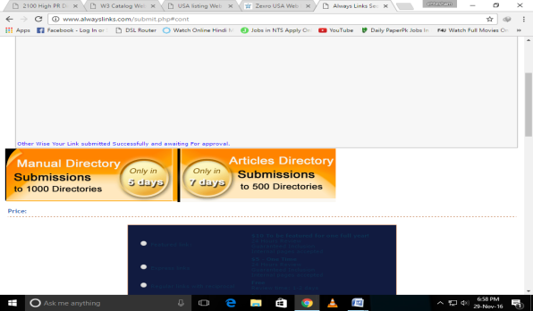
18 | http://www.usalistingdirectory.com/submit.php | 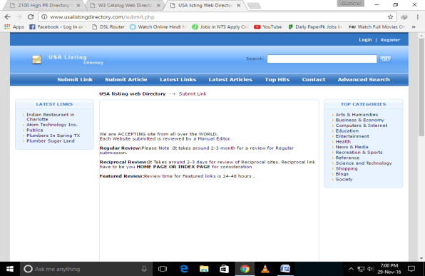
19 | http://www.w3catalog.com/submit.php | 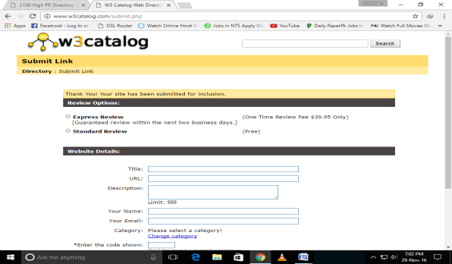
20 | http://www.nonar.com/submit.php?c=1382&LINK_TYPE=27 | 